COMMUNICATIONS UPDATE
communicate@blackburn.anglican.org


Thy Kingdom Come: News round-up
Message from our Bishops

It’s less than a week (May 24) until the Thy Kingdom Come beacon launch event for our Diocese at Blackburn Cathedral. Parishes from across the Diocese are invited to send people to the launch event, which begins at 7.30pm. Bishop Julian, Bishop Geoff and Bishop Philip have issued a joint message of encouragement to all parishes before Thy Kingdom Come begins which has also been issued to the local media. You can read the message by clicking here, and watch a video here about Thy Kingdom Come, featuring the Archbishop of Canterbury.
Beacon launch event
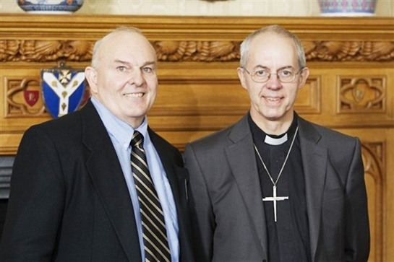
Our beacon launch event for Thy Kingdom Come is one of 29 across the country. It will take place at Blackburn Cathedral at 7.30pm on May 24. People from parishes across Lancashire will attend. The service will be led by Bishop Philip and the keynote speaker is Roy Crowne, who is the HOPE Together Executive Director and one of the founders of HOPE, a catalyst organisation that brings churches together to transform communities; a key aim of our own Diocesan Vision 2026. Although not necessary for attending, it would be helpful for numbers if you could book if you are coming to the Cathedral; just visit this page.
- While Roy Crowne (pictured right with the Archbishop of Canterbury) is visiting the Diocese he will front two special events earlier on May 24 (one am, one pm) for people in leadership positions in our churches. Find out more and book by clicking here for am and here for pm.
Thy Kingdom Come resources
Resources, for download and to order, are available on this page of the Diocesan website which also has links to the national Thy Kingdom Come website. And don’t forget to participate on social media local @cofelancs and nationally @thykingdom_come
Have you committed to #Pledge2Pray?
As well as organising and participating in parish and Diocesan events, individuals; families and churches can also #Pledge2Pray during Thy Kingdom Come by adding their details here and they will then receive regular updates and useful links throughout the 10 days

Welcome banners
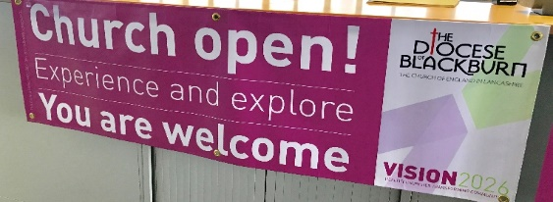
The theme of this year’s Deanery Visitations is ‘welcome’ and the Archdeacons are encouraging parishes to be open as much as possible during the period of Thy Kingdom Come and then beyond over the summer. Pre-designed welcome banners can still be ordered for inside or outside your church. The vinyl external banner (right) is just £45 and the internal pop-up banner is £99. Email karen.ashcroft@blackburn.anglican.org if you are interested, and to order.
Other recent news: A round-up of some other news stories …
Diocesan workshop focuses on outer estates ministry
A workshop led by Bishop Philip and involving representatives from estates churches from across Lancashire took place recently at St James' Church, Lower Darwen. The inspiring event was an opportunity for clergy and laity to get together, to network and share experiences. As delegates gathered, the first of the Diocese of Blackburn’s applications to the Church Commissioners’ Strategic Development Fund for £1.3m for ‘Outer Estates Leadership’ was being submitted. For more information, click here and click here for an album of pictures from the event.
Landmark New Wine Conference
Churches from across the Diocese attended this ecumenical conference in Lancaster recently. You can read a report here on the Diocesan website and click here for an album of pictures from the event.
Run for the World
This was another ecumenical event, which takes place annually, where people from across Lancashire pulled on their running shoes to help raise money – this year going towards setting up a new CAP debt centre in Morecambe. Report here and more pictures will also appear soon on our Flickr feed.
Spirituality Programme at Whalley Abbey
There is a packed programme for the rest of the year at our Abbey – with some great residential and single day events to choose from. Visit this page of the Diocesan website for more information.
Get Your Church Noticed
A chance to get top communications and marketing tips from Ronnie Semley, Diocesan Communications Manager who will be joined by Neil Pugmire, Communications Manager from Portsmouth Diocese. The first course, run last summer, was a great success. We run it again on Saturday, October 7 at the Diocesan Offices in Blackburn. Book your FREE place here.
Illumination lights up Blackpool
You may have seen media coverage of the new ‘resurrection illumination’ in Blackpool, in place for Easter and for the illuminations later this year, and every year. Money is still being raised. Read the news story and donate by visiting this page.

And finally … introducing Mark Ashley
Mark Ashley – who attends All Saints Church in Appley Bridge – will be working for a few hours each week on a voluntary basis as a Diocesan news reporter, writes Ronnie Semley, Diocesan Communications Manager. He will work alongside me to create a bit more capacity to tell even more good news stories about our work. Mark is a very experienced former journalist and for many years worked in newspaper management. He may be in touch with you at some point and I know the whole Diocese will make him welcome. I am grateful to Mark for sparing the time to assist us.

